ISSUE 1 and 4 resolved!!

Below ones are still pending

ISSUE 02:

When a user submits requirements, where CAN I SEE THE SUBMITTED FORM?

How is the information submitted? Sent By Email? To Which Email address if any.

After the User SUBMIT the info, where is posted / sent to?

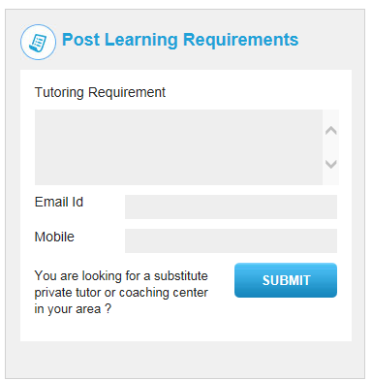

SG Reply: It will be just for collect data regarding student requirements.We will make a management for it.where admin can able to see all those requirements.

ISSUE 03:

<http://tutorarabia.com/forget_pass.html>

Forgot my password does not do anything?!!

No Email sent with new password!!!

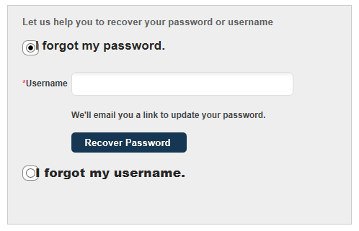

SG Reply: It’s done.

Issue05:

Subscribe to Newsletter does nothing?!!

Nothing Happens when click on subscribe button.



SG Reply: This one for newslatter.Newslatter was not implemented.Once you will make this we will make this functional

Issue06:

How do I make changes to “**Change username mail**” template?

SG Reply: Not understand. Please tell clearly.

This is an email I received after submitting a “**forgot my User Name**”!

My question is which email template was used to send this email? What is the template name? I can not find it under the Email template in the admin

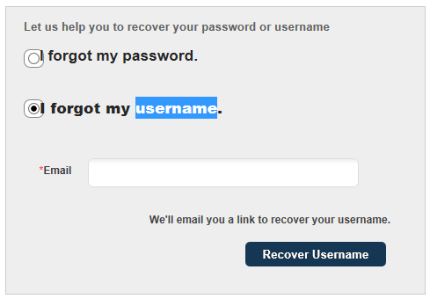

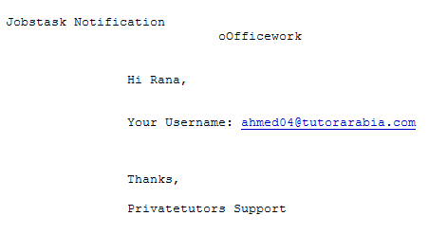

SG Reply: The template name is “recover_username”.

Issue07:

Mail Template management Search by ID Only?

SG Reply: Do you want more search options here??

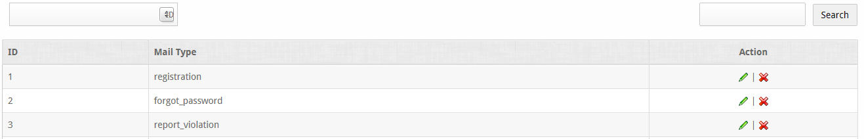

I need to be able to search with “Mail Type” Not just ID.

SG Reply: Now we add “Mail Type” as Search params.